Sharekatcom application

*team:*

|  |  |
| --- | --- |
| Sami Abdul Kareem Alsanabrah | 202010437 |
| Ahmed Jamal Karzoun | 201910082 |
| Anas Ibrahim aljawabrah | 202130057 |

Team leader: Ahmed Jamal Karzoun

Tools and Technologies Used:

1.Flutter

2. Firebase

3. Android Studio

4. GitHub

Cover Page

Software Project Management Plan (SPMP)

Sharekatcom application

Version: 1.0.0

2/8/2023

link GitHub: <https://github.com/ahmadkarazou/Sharekatcom>

Amane Arabah University

Revisions Page

|  |  |  |  |
| --- | --- | --- | --- |
| Version | Primary Author | Description of Version | Date Completed |
| 1.0.0 | Ahmad Karzoun | Project start | 2/8/2023 |

Table Of Contents

1 INTRODUCTION

* 1. Project Overview
  2. Project Deliverables

1. PROJECT ORGANIZATION
   1. Software Process Model
   2. Roles and Responsibilities
   3. Tools and Techniques
2. PROJECT MANAGEMENT PLLAN
   1. Tasks

3.1.1 Task-1

3.1.1.1 Description

3.1.1.2 Deliverables and Milestones

3.1.1.3 Resources Needed

3.1.1.4 Dependencies and Constraints

3.1.1.5 Risks and Contingencies

3.1.2 Task-2

3.1.2.1 Description

3.1.2.2 Deliverables and Milestones

3.1.2.3 Resources Needed

3.1.2.4 Dependencies and Constraints

3.1.2.5 Risks and Contingencies

3.1.3 Task-3

3.1.3.1 Description

3.1.3.2 Deliverables and Milestones

3.1.3.3 Resources Needed

3.1.3.4 Dependencies and Constraints

3.1.3.5 Risks and Contingencies

3.1.4 Task-4

3.1.4.1 Description

3.1.4.2 Deliverables and Milestones

3.1.4.3 Resources Needed

3.1.4.4 Dependencies and Constraints

3.1.4.5 Risks and Contingencies

3.1.5 Task-5

3.1.5.1 Description

3.1.5.2 Deliverables and Milestones

3.1.5.3 Resources Needed

3.1.5.4 Dependencies and Constraints

3.1.5.5 Risks and Contingencies

3.1.6 Task-6

3.1.6.1 Description

3.1.6.2 Deliverables and Milestones

3.1.6.3 Resources Needed

3.1.6.4 Dependencies and Constraints

3.1.6.5 Risks and Contingencies

3.1.7 Task-7

3.1.7.1 Description

3.1.7.2 Deliverables and Milestones

3.1.7.3 Resources Needed

3.1.7.4 Dependencies and Constraints

3.1.7.5 Risks and Contingencies

3.1.8 Task-8

3.1.8.1 Description

3.1.8.2 Deliverables and Milestones

3.1.8.3 Resources Needed

3.1.8.4 Dependencies and Constraints

3.1.8.5 Risks and Contingencies

3.1.9 Task-n

3.1.9.1 Description

3.1.9.2 Deliverables and Milestones

3.1.9.3 Resources Needed

3.1.9.4 Dependencies and Constraints

3.1.9.5 Risks and Contingencies

3.1.10 Task-n

3.1.10.1 Description

3.1.10.2 Deliverables and Milestones

3.1.10.3 Resources Needed

3.1.10.4 Dependencies and Constraints

3.1.10.5 Risks and Contingencie

3.2 Assignments

3.3 Timetable

Introduction

1.1 PROJECT OVERVIEW

Sharekatcom is an application that provides a service that increases the confidence of your business in front of your customers. The service facilitates access to target customers. Evaluate your customers and their comments on your page with Sharekatcom service.

It will show the quality of your services in front of everyone. The service is free, and all you have to do is download the application from the store and register in it. You can subscribe to the Sharekatcom application within a few seconds. The service provided by the application is easy, useful, and confidential. Your data is guaranteed. You can obtain important information about the electronic stores registered in Sharekatcom. The user or seller can view evaluation of previous customers of electronic stores, and the service provides you with the ability to evaluate any online store registered in Sharekatcom.

1.2 PROJECT DELVERABLES

The application aims to address the problems view reliable companies by providing a service to search for companies and services, and owners of companies and service providers to manage and promote them. The aims make the process of searching for companies and service providers easier, safer and more reliable.

2 PROJECT ORGANIZATION

2.1 SOFTWARE PROCESS MODEL

The system development life cycle (SDLC) involves a structured approach to planning, creating, and maintaining a system, which includes identifying the requirements, designing the system building and testing the system, implementing the system, and maintaining it. Fig. 2 shows the main steps of SDLC

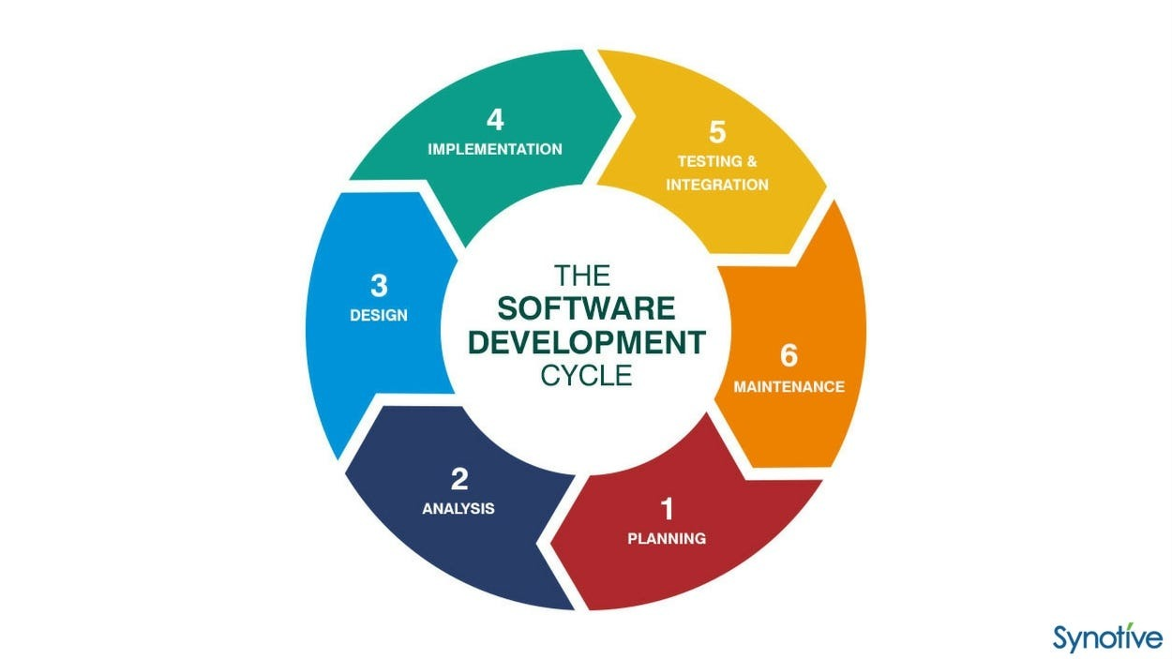

2.2 ROLES AND RESPONSIBILITIES

|  |  |
| --- | --- |
| Sami Abdul Kareem Alsanabrah | System  Analysis |
| Ahmed Jamal Karzoun | TEAM  LEDAR |
| Anas Ibrahim aljawabrah | System Design |

2. 3 Tools and Technologies Used

For the Sharekatcom application, we will use the following tools and technologies. Mobile application:

1.Flutter: is an open-source mobile application development framework created by Google. It allows developers to build high-quality, natively compiled mobile applications for both Android and iOS platforms with a single codebase. Flutter uses the Dart programming language and offers a modern reactive programming model, a flexible UI toolkit, and extensive support for various third-party packages and plugins for advanced functionalities. With its hot reload feature and easy-to-use development tools, Flutter has gained popularity among developers for its faster development process and excellent performance.

2. Firebase: is a mobile and web application development platform that provides a set of tools and services such as databases, authentication, hosting, and storage. We will be using Firebase to handle the backend of the application, including user authentication, data storage, and real-time updates.

3. Android Studio: is the official Integrated Development Environment (IDE) for developing Android apps. It provides a set of tools and features that make it easy to develop, test, and deploy Android applications. We will be using Android Studio to develop the mobile application.

4. GitHub: is a web-based hosting service for Git repositories. It allows for easy collaboration, code review, and issue tracking. We will be using GitHub to host and share the source code for this project. These tools and technologies have been chosen for their reliability, scalability, and ease of use. They have a well-established track record in the industry.

1. PORJECT MANAGEMENT PLLAN

3.1Tasks

3.1.1 Task-1

3.1.1.1 Description

Gather requirements from the client

3.1.1.2 Deliverables and Milestones

Requirements from the processes that must be in the application

on the date 3/8/2023

3.1.1.3 Resources Needed

A meeting was held with a group of company owners and company

searchers on social media

3.1.1.4 Dependencies and Constraints

Communicate with people interested in grouping companies in one place

3.1.1.5 Risks and Contingencies

­Ensure clarity of customer data

3.1Tasks

3.1.2 Task-2

3.1.2.1 Description

Data analysis of business owners

3.1.2.2 Deliverables and Milestones

Collect data in one place to be classified

on the date 5/8/2023

3.1.2.3 Resources Needed

Data storage, computer and internet

3.1.2.4 Dependencies and Constraints

depends on task-1

3.1.2.5 Risks and Contingencies

Loss of data from the computer he solution is to take a backup copy on a flash memory

3.1Tasks

3.1.3 Task-3

3.1.3.1 Description

Analyzing user data

3.1.3.2 Deliverables and Milestones

Collect data in one place to be classified

on the date 5/8/2023

3.1.3.3 Resources Needed

Data storage, computer and internet

3.1.3.4 Dependencies and Constraints

depends on task-1

3.1.3.5 Risks and Contingencies

Loss of data from the computer he solution is to take a backup copy on a flash memory

3.1Tasks

3.1.4 Task-4

3.1.4.1 Description

Develop requirements for the application and organize them clearly

3.1.4.2 Deliverables and Milestones

Determine the final requirements

on the date 6/8/2023

3.1.4.3 Resources Needed

Data storage, computer and internet

3.1.4.4 Dependencies and Constraints

depends on task-2 depends on task-3

3.1.4.5 Risks and Contingencies

Loss of data from the computer he solution is to take a backup copy on a flash memory

3.1Tasks

3.1.5 Task-5

3.1.5.1 Description

On the system diagrams (use case ,activity diagrams, sequins diagrams )

3.1.5.2 Deliverables and Milestones

Clarity in applicable designs

on the date 7/8/2023

3.1.5.3 Resources Needed

Data storage, computer and internet

3.1.5.4 Dependencies and Constraints

depends on task-4

3.1.5.5 Risks and Contingencies

Loss of data from the computer he solution is to take a backup copy on a flash memory

3.1Tasks

3.1.6 Task-6

3.1.6.1 Description

Design of user interfaces to be linked with the system

3.1.6.2 Deliverables and Milestones

user interfaces

on the date 10/8/2023

3.1.6.3 Resources Needed

Data storage, computer and internet, Android Studio

3.1.6.4 Dependencies and Constraints

depends on task-5

3.1.6.5 Risks and Contingencies

Loss of data from the computer he solution is to take a backup copy on a flash memory

3.1Tasks

3.1.7 Task-7

3.1.7.1 Description

Create the logical operations on which the application is based

3.1.7.2 Deliverables and Milestones

logical operations

on the date 15/8/2023

3.1.7.3 Resources Needed

Data storage, computer and internet, Android Studio

3.1.7.4 Dependencies and Constraints

depends on task-5

3.1.7.5 Risks and Contingencies

Loss of data from the computer he solution is to take a backup copy on a flash memory

3.1Tasks

3.1.8 Task-8

3.1.8.1 Description

Connect user interfaces with the logical operations performed by the application

3.1.8.2 Deliverables and Milestones

Application without databases

on the date 20/8/2023

3.1.8.3 Resources Needed

Data storage, computer and internet, Android Studio

3.1.8.4 Dependencies and Constraints

depends on task-6 depends on task-7

3.1.8.5 Risks and Contingencies

Loss of data from the computer he solution is to take a backup copy on a flash memory

3.1Tasks

3.1.9 Task-9

3.1.9.1 Description

Create databases for the application

3.1.9.2 Deliverables and Milestones

data base

on the date 22/8/2023

3.1.9.3 Resources Needed

Data storage, computer and internet, Firebase

3.1.9.4 Dependencies and Constraints

depends on task-8

3.1.9.5 Risks and Contingencies

Loss of data from the computer he solution is to take a backup copy on a flash memory

3.1Tasks

3.1.10 Task-10

3.1.10.1 Description

Connect the database with the application

3.1.10.2 Deliverables and Milestones

application

on the date 25/8/2023

3.1.10.3 Resources Needed

Data storage, computer and internet, Firebase, Android Studio

3.1.10.4 Dependencies and Constraints

depends on task-8 depends on task-9

3.1.10.5 Risks and Contingencies

Loss of data from the computer he solution is to take a backup copy on a flash memory